Dear Mr. Panetta,

Kindly find attached paper entitled “Building Wind Farms Next to Series Capacitor Banks: Lessons Learned” which we are submitting for exclusive consideration for the 2017 IEEE IAS Annual meeting.

Wind farms have attracted much attention in recent years as a viable energy resource. Historically, wind farms have been built either in remote areas where transmission capacity is scarce or near highly congested transmission lines which necessities installing series capacitor banks to relieve transmission line congestion. The paper attached deals with the latter case in which a wind farm was built close to a series capacitor bank. One phenomenon was observed while performing subsynchronous resonance analysis during the design phase of the project and is described in the paper in detail.

Given the breadth and the depth of the EMT simulations carried out in this paper, we think that the paper is a valuable addition to literature which we hope you agree to and consider it for review for the 2017 IEEE IAS Annual meeting.

Finally, we hope you and the reviewers find the paper enjoyable as we found it during preparation, simulation, writing and proof reading.

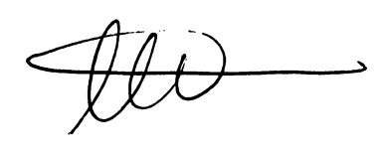

Ahmad Abdullah

Power System Design Engineer

Electric Power Engineers Inc.,

Austin, TX, 78738